Orchestration Flow
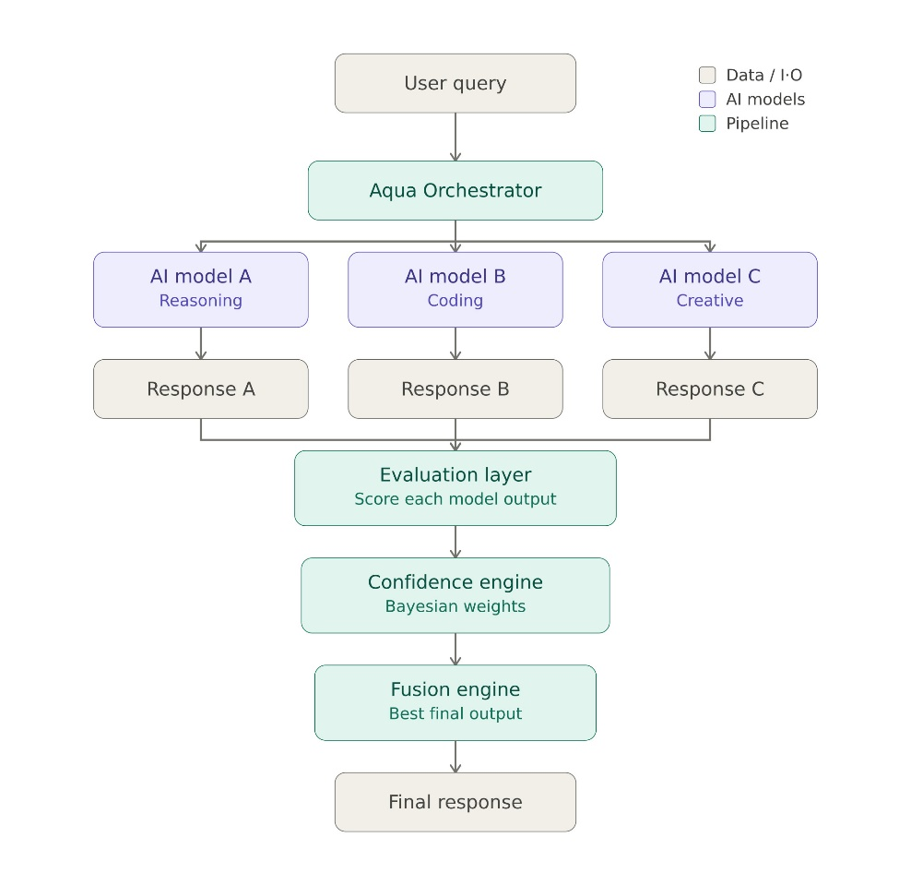

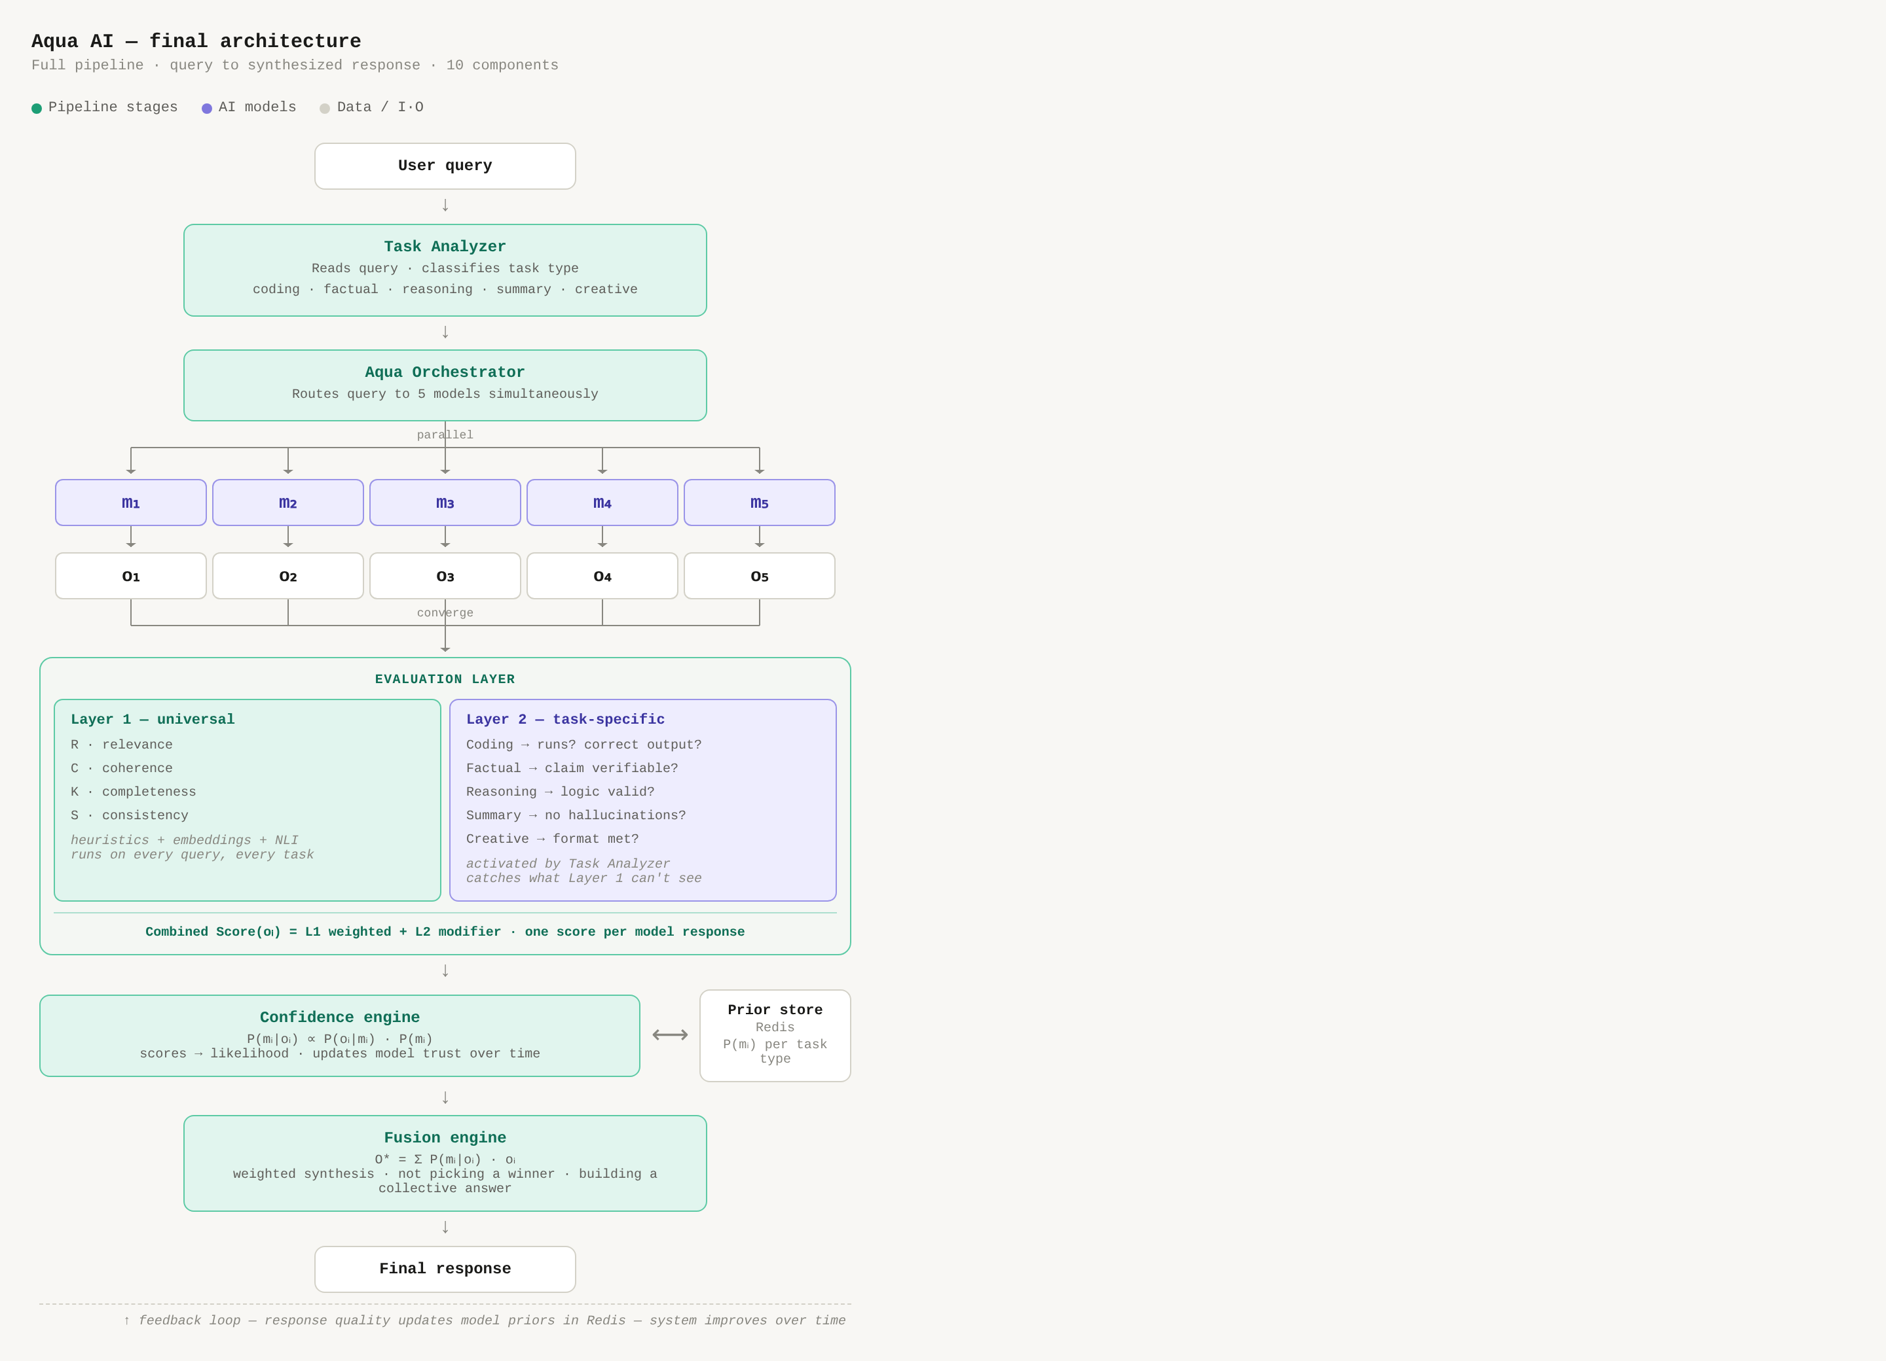

1. System Overview
This architecture is a multi-model, orchestration pipeline.
It is designed to route user queries to specialized AI models, mathematically evaluate their outputs in real-time, and fuse the results using a continuously updating bayesian trust system.

2. Phase 1: Ingestion & Task Analysis
The lifecycle begins when a user submits a prompt to the system.
• The Ingestion Node: The User query is received by the Aqua Orchestrator.
• Task Analyzer (Classifier): Before routing, the orchestrator analyzes the semantic intent of the query to classify the Task Type.

• Classification Categories: The system maps the query to predefined domains, such as Reasoning, Coding, or Creative.

3. Phase 2: Fan-Out & Asynchronous Generation
Once classified, the Orchestrator executes a "fan-out" strategy to leverage multiple specialized models simultaneously.
- Expertise Mapping: Each model processes the query using its specialized weights (eg model A handles reasoning logic, model B writes code, model C handles creative)
- Collection: The raw outputs (response A, response B, response C) are temporarily added in memory to be passed to the scoring layer.

4. Phase 3: Evaluation Layer
- The Evaluation Layer: All buffered responses are passed through a heuristic scoring layer. each model’s output is assigned a raw evaluation score between 0.0 and 1.0.
- The confidence engine (bayesian layer):
- The system retrieves the current historical trust score, which is the prior for each model based on the specific task type determined in phase 1.
- Using bayes theorem the engine factors the new evaluation score against the historical Prior.
- An Exponential Moving Average (Learning Rate α = 0.2) is applied to dampen the update, preventing a single anomaly from crashing a model's reputation.
- The updated scores are saved back in json for the next query.

5. Phase 4: The Fusion Engine
With all responses generated and mathematically scored, the system determines the best possible output for the user.
- Weight Normalization: The updated Bayesian trust scores are normalized into percentages that sum to 100%
- Response Blending (Fusion): The Fusion Engine uses these normalized weights to select or blend the final output. In Version 1, the Fusion Engine doesn't pick a winner. It synthesizes a collective answer. The highest confidence response becomes the base, and other trusted responses fill in gaps the base missed. The final output reflects all models, weighted by their posterior confidence.
- Final Delivery: The synthesized response is packaged and delivered to the user interface as the Final response.

6. Summary of Data Flow
Pipeline Stage | Active Component | Primary Action | Data State
Ingestion | Aqua Orchestrator | Intent Classification | Raw User Text → Task Type
Generation | AI Models (A, B, C) | Parallel Inference | Task Type → Raw Responses
Scoring | Evaluation Layer | Heuristic Grading | Raw Responses → Likelihood Scores
Learning | Confidence Engine | Bayesian Update | Likelihood Scores → Updated Priors
Resolution | Fusion Engine | Weight-based Synthesis | Updated Priors → Final Response
Week 4 Updates:
User Query
↓
Task Analyzer → classifies task type
↓
AQQAI Orchestrator → fans out to 5 models
↓
5 responses collected
↓
Evaluation Layer
Layer 1: R, C, K, S (universal)
Layer 2: task-specific checks
↓
process_confidence_request()
→ Bayesian update
→ Inter-model agreement calculation
→ Dynamic Fusion weights (sharpened or flattened)
↓
fuse_responses()
→ Weighted sentence blending (Semantic threshold < 0.75)
→ Final response
↓
Logged and returned

